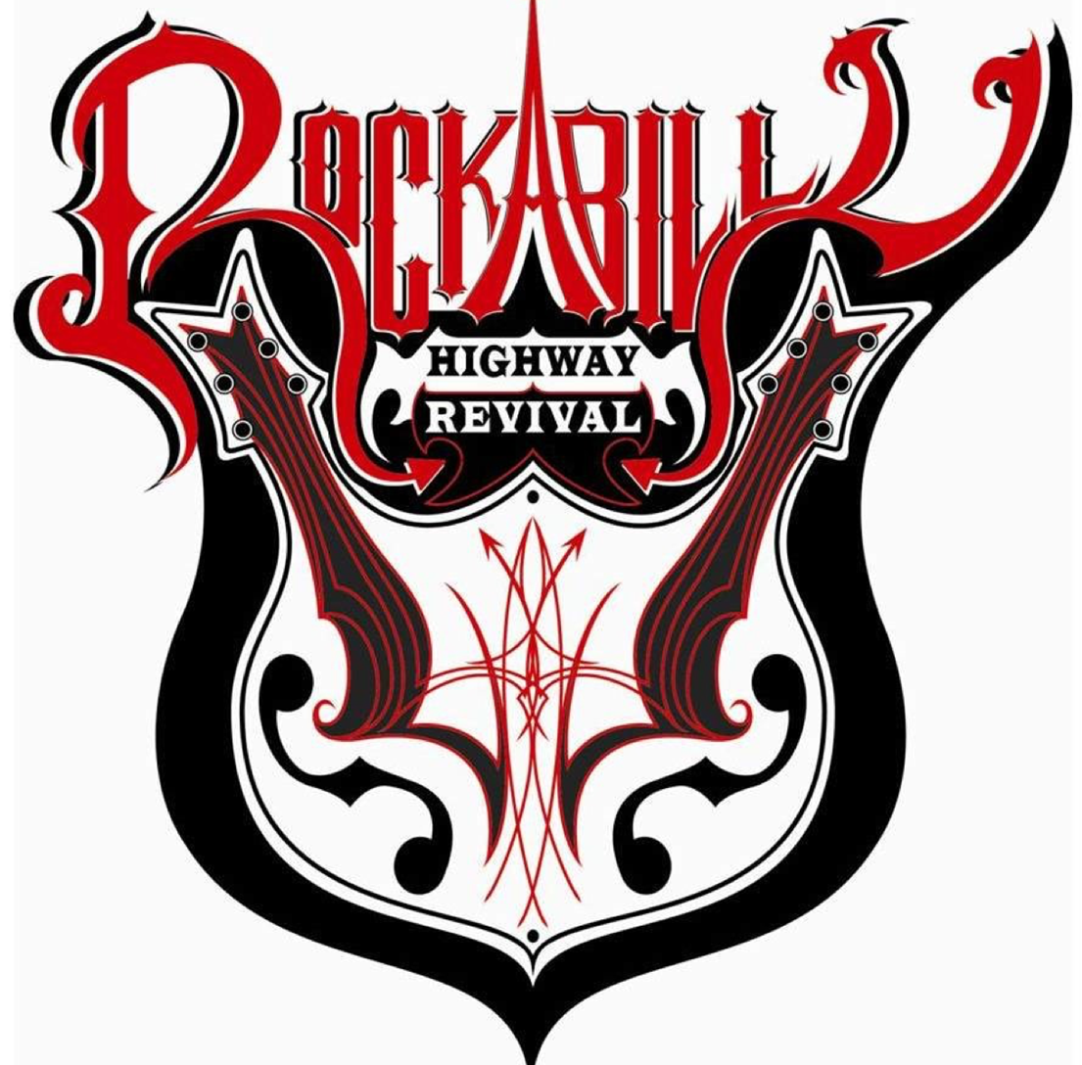
2018 Rockabilly Vendor Application
Food/Vendors that are interested in being a part of this event should submit this form no later than June 1, 2018 Please email applications to: jessica@mcnairy.com or return to the McNairy County Chamber at 205 W Court Ave in Selmer. All vendor spaces are 10’ wide by 10’ deep. All vendors are required to display a certificate of Insurance naming Town of Selmer and McNairy County EDC & Chamber of Commerce as co-insured.
All vendor fees will be waived for 2018, we ask that you donate 10% of your proceeds back to the Rockabilly Highway Revival fund at the end of the day.
Vendor Name: ___________________________________________________________________________________
Contact Name: ___________________________________________________________________________________
Phone: _________________________________________ Email: __________________________________________
Address: ________________________________________________________________________________________
Will you need electricity? Yes/No
Amps _____ (Electricity is limited so please let us know if you will be providing your own generator)
All Vendors must be set up no later than 1:00pm on June 9th
Please list item/service you will be selling/providing:

For additional information, please contact:
Jessica Huff, Tourism Director
731-645-6360
*TheEventHelper.com, this program has been designed to meet the needs of venues and facilities that require their vendors to secure their own private vendors insurance, food vendor insurance and performers insurance coverage.

